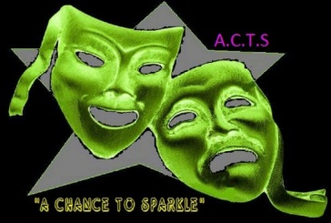
A.C.T.S A Chance To Sparkle
Daisy House
Upton Scudamore
Wiltshire
BA12 0AE

07740 471753
musiclessons@achancetosparkle.com
www.achancetosparle.com

Dear Parent/Guardian.
By continuing to take music lessons provided by ‘A Chance To Sparkle’ you agree to the following terms and conditions.
- Invoices will be issued by email, failure to make the payments before or on the due date could result in the lessons being postponed until payment has been received in full.

- All fees are set out on our website at all times and at least 4 weeks notice will be given in writing of any change to these fees.

- You must notify us in writing if your email address changes since your order for your lessons.

- You will not be charged for any sessions which were not taught due to tutor illness or other unforeseen circumstances resulting in the tutor’s absence. The subsequent invoice will be adjusted to reflect this absence.

- Refunds cannot be given for instrumental lessons missed due to pupil illness, absence without notice or unauthorised absence.

- Lessons missed due to school trips will not be charged for if notice is given before the term begins but will be treated as an absence as above if this notice is not given – please do not rely on the school passing on this information to us!

- If a lesson is not delivered due to inclement weather where the teacher is unable to reach the venue for the lesson but the venue remains open then a full refund will be issued in the subsequent invoice

- If the school is closed due to inclement weather or otherwise resulting in the loss of a paid lesson, refunds can not be given via A.C.T.S. It will be at the school’s discretion as to whether they will be able to help with the financial loss more directly.

- At least 4 weeks’ notice is required by both parties to cancel instrumental lessons – if less than this is given then you will still be charged for the lessons until the 4 week period has ended.

- Practice between sessions is directly related to progress so please encourage this whenever you can in order that the most can be made from the lessons and try to continue this through the holiday period. A.C.T.S and their staff cannot be held responsible for slow progress due to a lack of practise.

- If there is no instrument available for practice purposes please do let us know as this can affect the direction of the lessons, and we can help you find a suitable instrument when it becomes necessary.

- All contact regarding the lessons should be directly through A.C.T.S and it is not necessary to go through the school office or any other body. We like to have a strong relationship with the parents of our students so do please feel free to contact us at any time whilst you order lessons through us.
The best contact to use at all times is by email: musiclessons@achancetosparkle.com

By all parties adhering to the terms as set out above we can ensure that all music lessons run smoothly, fairly and without confusion or conflict. We appreciate you taking the time to read these.

Many Thanks.

Mr C Turner
Director and founder
A.C.T.S - A Chance To Sparkle

